CS5491 AI Project：

Automated Heuristic Design via Large Language Models
A Heuristic is a function that estimates how close a candidate solution is to a goal; for example, Euclidean distance (straight-line distance) between two cities is a heuristic for estimating how close a city is to the goal city. Traditionally, heuristics are designed manually by human experts via tedious trial-and-error. In this project, we would like to explore how the design of a heuristic can be formulated as a search problem and how we can leverage large language models (LLMs) to search over the space of heuristics and find better heuristic functions for a given problem.

Specifically, let us consider the online bin packing problem we discussed in class as an example. To recap, the bin packing problem is an optimization problem in which items of different sizes must be packed into a finite number of bins or containers, each of a fixed given capacity, to minimize the number of bins used. Then, in an online bin packing problem, items of different volumes are supposed to arrive sequentially, and the decision maker has to decide whether to select and pack the currently observed item or let it pass. Each decision is without recall. See the figure below for a pictorial illustration.
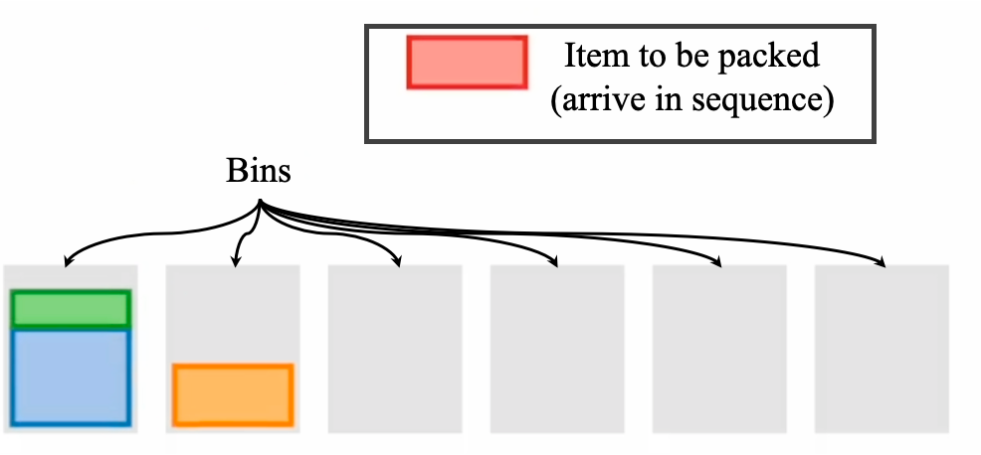

A generic template of the heuristic for online bin packing problems can be coded via Python as follows:
def heuristic(bins, item):
# input arguments:
# bins: the current capacities of each bin
# item: the size of the item to be packed
# output:
# index of the bin for holding the item
# ------------ start of heuristic function -------------- #
index = ... # to be determined
# ------------ end of heuristic function -------------- #
return index

Then, a simple heuristic to “Pack items according to remaining capacities of the bins” can be implemented as follows:
def heuristic(bins, item):
# input arguments:
# bins: the current capacities of each bin
# item: the size of the item to be packed
# output:
# index of the bin for holding the item

# ------------ start of heuristic function -------------- #
# the remaining capacity of each bin if the item is placed in every bin
remaining_capacity = bins - item
# find the index of the bin with least capacity remaining
index = argmin(remaining_capacity)
# ------------ end of heuristic function -------------- #
return index

Now, instead of relying on human intuitions or manual trial-and-errors to find a better heuristic, we would like to automate the design process by treating it as a search problem. One successful realization of this idea is presented in a recent Google Deepmind paper published in Nature: Mathematical discoveries from program search with large language models. The method is called FunSearch, and the main idea is illustrated in the following figure:
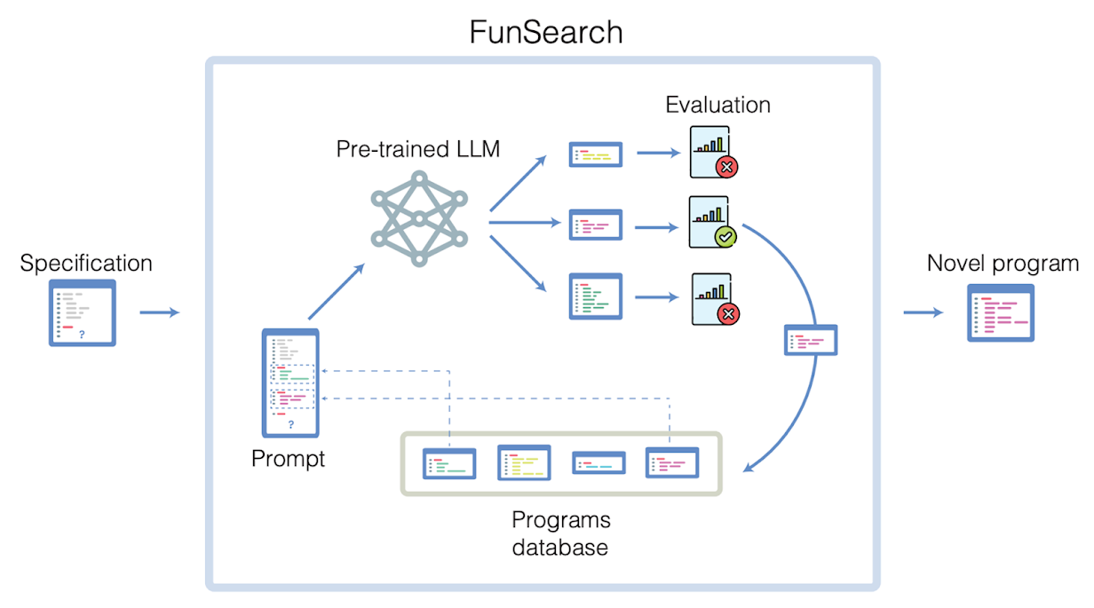
Figure credits: https://www.nature.com/articles/s41586-023-06924-6

FunSearch refers to a heuristic function as a program. FunSearch first asks an LLM to create a set of programs, each of which will be incorporated into the general heuristic code template, as shown above. Each program will be evaluated on some test instances of the online bin packing problems, and the resulting performance will be recorded. Then, the main loop of FunSearch starts, where in each iteration, FunSearch picks a promising program (in terms of performance) from the set of programs created before. This program will be sent to an LLM for further modifications so that the performance can be improved. Then, the modified program is evaluated (again, on some test instances of the online bin packing problem), and it will replace the original program if its performance improves. This process will repeat for many iterations until a novel program is obtained or some pre-defined max # of iterations is reached.

Useful resources:
- FunSearch
  - Paper: https://www.nature.com/articles/s41586-023-06924-6
  - Blog post: https://deepmind.google/discover/blog/funsearch-making-new-discoveries-in-mathematical-sciences-using-large-language-models/
  - Official implementation by Google Deepmind: https://github.com/google-deepmind/funsearch/tree/main (note that this implementation does NOT include the codes for (i) LLM interface and (ii) performance evaluation of a program (referred to as “sandbox” in the code).
- Online bin packing problem:
  - Datasets:
OR dataset (http://people.brunel.ac.uk/~mastjjb/jeb/info.html )
WeiBull dataset (http://mistic.heig-vd.ch/taillard/problemes.dir/ordonnancement.dir/ordonnancement.html )

  - A Jupyter notebook comparing the performance of the heuristics designed by human experts and by FunSearch is provided by Google Deepmind at https://github.com/google-deepmind/funsearch/blob/main/bin_packing/bin_packing.ipynb
- FunSearch on online bin packing problem
  - We provide a functional implementation of FunSearch on online bin packing problems for you:
  - (Google Colab) bin_packing_funsearch.ipynb
  - (Github) https://github.com/RayZhhh/funsearch

- Other related works:
  - AEL: https://arxiv.org/abs/2311.15249
  - GLS: https://arxiv.org/abs/2401.02051
  - AlphaGeometry: https://deepmind.google/discover/blog/alphageometry-an-olympiad-level-ai-system-for-geometry/

Potential project topics:
- Application to other search problems beyond packing, for example:
  - Traveling salesman problem (TSP)
    - A quick overview:
https://developers.google.com/optimization/routing/tsp
    - Datasets / Benchmark test suites
      - TSPLib http://comopt.ifi.uni-heidelberg.de/software/TSPLIB95/
      - TSPLib Symmetric (Recommend) http://comopt.ifi.uni-heidelberg.de/software/TSPLIB95/tsp/
    - Existing heuristics / algorithms designed by human experts
      - Constructive Heuristics (nearest, cheapest, farthest) https://github.com/wouterkool/attention-learn-to-route/blob/master/problems/tsp/tsp_baseline.py
      - Commercial solver (Gurobi) https://github.com/wouterkool/attention-learn-to-route/blob/master/problems/tsp/tsp_gurobi.py
      - SOTA heuristic solver (LKH) source in C http://webhotel4.ruc.dk/~keld/research/LKH-3/ python wrapper https://github.com/ben-hudson/pylkh
      - Neural Solver (AM, POMO) https://github.com/wouterkool/attention-learn-to-route/tree/master, https://github.com/yd-kwon/POMO
      - Google OR-Tools
  - Flow job shop scheduling
    - A quick overview: https://developers.google.com/optimization/scheduling/job_shop (flow shop scheduling is a special case of job shop scheduling with all jobs having the same execution order)
    - Dataset / benchmark:
      - OR-Library http://people.brunel.ac.uk/~mastjjb/jeb/info.html
      - Taillard dataset http://mistic.heig-vd.ch/taillard/problemes.dir/ordonnancement.dir/ordonnancement.html
      - VRF dataset http://soa.iti.es/problem-instances
    - Existing heuristics / algorithms designed by human experts
      - Google OR-Tools
      - Some simple heuristics https://github.com/KamilGos/flowshop-scheduling

  - Capacitated Vehicle Routing Problem (CVRP)
    - A quick overview:
https://developers.google.com/optimization/routing/cvrp
    - Dataset / benchmark:
      - CVRPLib http://vrp.atd-lab.inf.puc-rio.br/index.php/en/
Uchoa et al, A,B,E,F,M,P Sets (Recommend)
      - Top CVRPTW, PDPTW https://www.sintef.no/projectweb/top/
    - Existing heuristics / algorithms designed by human experts
      - A collection of 15 classical heuristics for CVRP (https://github.com/yorak/VeRyPy)
      - Google OR-Tools
      - One of SOTA heuristic solvers (LKH) source in C http://webhotel4.ruc.dk/~keld/research/LKH-3/ python wrapper https://github.com/ben-hudson/pylkh
      - One of SOTA heuristic solvers (HGS) source in C https://github.com/vidalt/HGS-CVRP
      - Neural Solver (AM, POMO) https://github.com/wouterkool/attention-learn-to-route/tree/master, https://github.com/yd-kwon/POMO
      - SOTA heuristic for large scale CVRP https://github.com/vinymax10/AILS-CVRP/tree/main

  - More problems are available from https://developers.google.com/optimization/introduction/python

Note that it is not enough to apply FunSearch to a new problem simply. We expect to see some form of novelty (e.g., developing a modified version of FunSearch for your specific problem) for the project.
- FunSearch enhancements. FunSearch provides a simple and generic implementation of the idea that uses LLM to automate the heuristic design as program/code search. Under this topic, we seek enhancements to make FunSearch more effective, efficient, and robust. Some potential ideas to get you started are as follows. (Note that it is okay to use the online bin packing problem for this topic; feel free to use other problems you may desire.)

  - “Thoughts–augmented FunSearch”
In addition to codes, can we also use thoughts/ideas, expressed as natural language descriptions/texts, to enhance the performance of FunSearch. For example, we can supply a short description of what the heuristic should do and its corresponding codes to LLM and see if LLM can generate better heuristics faster.
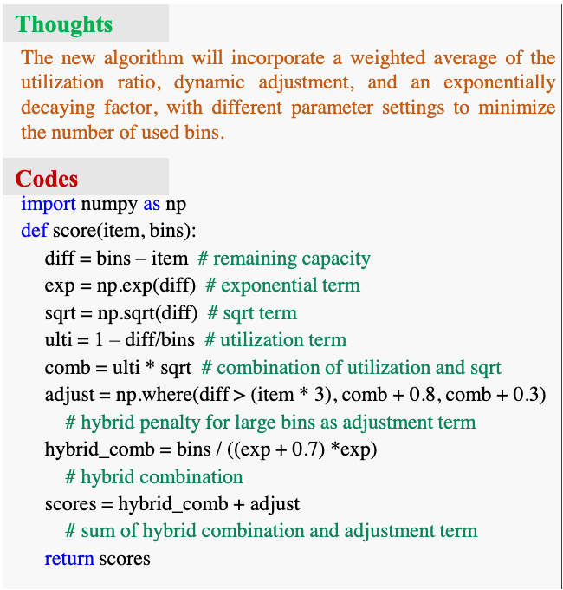

  - “Sample-efficient FunSearch”
Many programs/codes will be created as FunSearch progresses. The chance of a newly sampled program/code being functionally similar to an existing sampled/evaluated program will increase. Instead of assessing blindly all programs/codes created by an LLM, can we design a duplicate code-checking mechanism to avoid FunSearch evaluating a code that has been previously evaluated? This duplicate code-checking mechanism should be quick enough to execute (i.e., ideally, it should take less time to check for duplicates than to evaluate the performance).
Note that the similarity between two programs/codes should be defined at the functionality level; see below for two different Python codes that calculate the mean of a list of numbers. Although they look different, they have the same functionality:
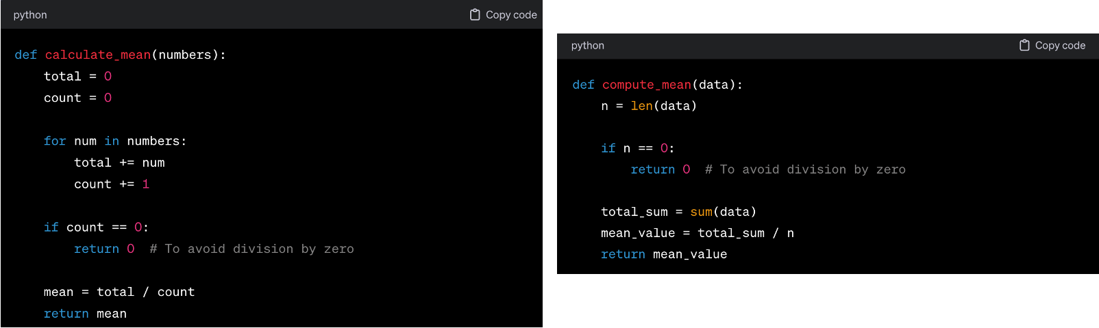
  - “Novelty-driven FunSearch”
Instead of always finding the best (in terms of some performance metric) solutions, we often would like to explore different ways to solve the same problem in real-world situations. In our context, this means that we would like to find programs/codes with diversely different behaviors (in terms of functional logic), but can fulfill the same goal reasonably well. Take a look at Ken Stanley’s talk on “why greatness can not be planned?” to get some ideas on this topic. Essentially, we would like to replace the original search routine in FunSearch with the so-called “Novelty Search” algorithm, as described in the video.
  - “Multi-objective FunSearch”
In addition to performance, there are additional criteria that one may desire for a heuristic function, for example:
    - Interpretability, i.e., how easily can humans comprehend the obtained heuristic function?
    - Simplicity, i.e., one may desire simpler heuristics than complicated ones.
    - …
Can we add these criteria to the original FunSearch to find heuristics simultaneously satisfying these desired properties?
  - Heuristic-oriented search space and distance study.
Add distance function to measure the difference of heuristics; refer to the works on EC and coding distance in ML
Advanced population management, e.g., multi-population, maintain diversity, allow infeasible heuristics

- Adaption of FunSearch to Machine Learning applications. Instead of using LLMs to evolve programs/codes as heuristic functions to guide a search algorithm. Can you adapt the same idea to develop programs/codes for ML tasks?

  - “Neural Architecture Search”
A deep neural network’s (DNN) model can be expressed as Python codes using PyTorch or TensorFlow (see below for an example). Then, we can apply FunSearch to design a DNN model as a search problem.
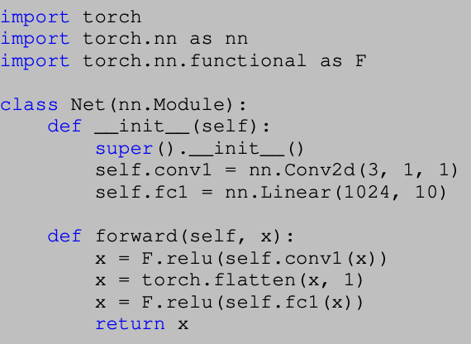
Resources:
    - Papers:
    - NAS Dataset / Benchmarks:
    - Other valuable materials to read:

  - “Robitcs Control”
The controlling logics of a robot can also be expressed as a program/code, in this case, we can apply FunSearch to automatically find a program/code to control the robotic for performing certain tasks.
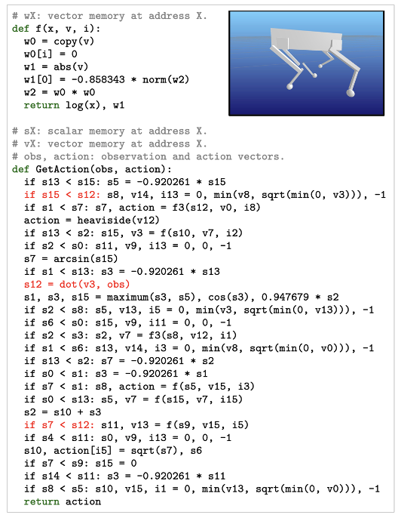
Resources
    - Papers: https://arxiv.org/abs/2307.16890
    - Video: https://www.youtube.com/watch?v=sEFP1Hay4nE
  - Game playing, …

